**COMPUTER PROJECT**

**LIBRARY MANAGEMENT SYSTEM**

**Name:**

**Class:**

**DELHI PUBLIC SCHOOL BANGALORE SOUTH**

**CERTIFICATE**

NAME:

CLASS:

ROLL NUMBER:

This is the certified to be the bona fide work of the student in the COMPUTER PROJECT during the academic year 2020-2021.

Teacher incharge: External examiner:

Principal signature: School seal:

Date:

**OBJECTIVE**

* This project is built to handle the primary functions of a library. Libraries can rely on this library management system to manage books and relationships with their members.
* The project helps to keep a tract of book issues, returns and member profiles.
* It displays books and member lists and fetches book or member searched.

**PROBLEM DEFINITION**

1. **Sign up: 3 Entry widgets**
   1. **Username: String**
   2. **Password: String**
   3. **Password Confirmation: String**
2. **Log in : 2 Entry widgets**
   1. **Username:String**
   2. **Password: String**
3. **Add Book: 3 Entry widgets**
   1. **Book name:String**
   2. **Book author: String**
   3. **Number of books: Integer**
4. **Delete Book: 1 Entry widget**
   1. **Book ID: String**

**Error Handling for the Addition and Deletion of Books:**

Every book that is added gets a unique Book id generated by the system in ascending order(eg. B1,B2…). When a book is deleted from the database the Book ID associated is deleted too. Instead of generating a new id to the added book, the new book is saved with the deleted book ID.

**5. Update Number of Books: 2 Entry widgets**

* 1. **Book ID: String**
  2. **New number of Books: Integer**

**6. Issue Books: 2 Entry Widgets**

**6.1 Book ID: String**

**6.2 Member ID : String**

**7**. **Add Member: 1 Entry widget and 2 Dropdowns**

**7.1 Name: String**

**7.2 Class: Dropdown**

**7.3 Section: Dropdown**

**8. Delete Member: 1 Entry Widget**

**8.1 Member ID: String**

**Error Handling for the Addition and Deletion of Members:**

Every member that is added gets a unique Member ID generated by the system in ascending order(eg. M1,M2…). When a member is deleted from the database the Member ID associated is deleted too. Instead of generating a new id to the newly added Member, the new Member is saved with the deleted Member ID.

**ANALYSIS**

1. INPUTS – DESCRIPTION

* On the first window of the project there are log in and sign up keys. In the sign up window your name and password can be entered which is saved to a text file.
* After logging in we can add a book by entering books name, author of the book and the number of books and internally a book id is assigned to the book.
* We can also delete a book by entering book id.
* We can update number of books by entering the book id and the new number of books.
* We can issue books to members by entering the book id and member id.
* We can return books by again entering member id and book id.
* To add members we can go to the member tab in the task bar where there are two options add member and delete member.
* To add a member we input members name, class and section and internally a member id is assigned to them.
* To delete a member we input their member id.
* To search for book’s information we go to the search tab in the taskbar and select search booklist. Then you can proceed to enter the name of the book whose information you need.
* To search for member’s information we go to the search tab in the taskbar and select search member list. Then you can proceed to enter the name of the member whose information you need.

2. OUTPUTS – DESCRIPTION

* On the sign up window if the username is shorter than 4 characters or password is shorter than 6 characters a error window popups.
* If the password and confirmation password aren’t same a error window popups
* If password is entered wrong 3 times in the log-in window it kills the program
* On the Log-in window, after entering username and password a loading window pops up with a loading bar
* When we add a new book or a new member a confirmation window popups.
* Once submitted, the new book or member information is stored in the respective tables.
* When deleting a book or member if the ID doesn’t exist a error window popups
* When we delete a book or a member a confirmation window popups.
* Upon deletion the corresponding book or member record is deleted from the respective tables
* When we update the number of booksa confirmation window popups.
* When we issue a book to a member a confirmation window popups.
* When a book is returned a confirmation window popups.
* If a book is returned after a week, a window notifying the librarian that the book is returned late popups
* On the task bar we can search for the member’s and book’s list .
* In the members list, we can search for particular members and see their respective information and the books that they have borrowed
* In the books list, we can search for particular books and get information regarding the book like the author, number of books left and the list of members who have borrowed the book.

Delete book

Add book

SIGN UP

Update book

Issue book

Return book

LOG IN

DATABASE

CONNECTION

MAIN PAGE

BOOKS LIST

MEMBERS LIST

**LIST OF DATAFILES AND DATABASES**

1. Data file: Passwords

This file stores the username and password when someone signs in to the program.

While logging in the file is traversed and credentials are cross checked.

2. Database connection

The python program is connected to the database.

There are three tables in the database which are:

1.books: bid name bauthor

2. issued books mid bid time issued

3. members mid name class sec

**CODE**

from tkinter import *

from tkinter import ttk,messagebox

import mysql.connector as n

from PIL import ImageTk,Image

import time

from datetime import datetime,date

#primary windows

#1.first page

def firstpg():

global a

a=Tk()

a.title('library') #setting title

a.geometry('1000x667') #setting size of window

a.config(cursor="pirate")

#setting background image

my_pic=Image.open('images/bg.jpg')

resized=my_pic.resize((1000,667),Image.ANTIALIAS)

new=ImageTk.PhotoImage(resized)

label=Label(a,image=new)

label.pack()

#creating and placing frames

hf = Frame(a,bg="#FFBB00",bd=5)

hf.place(relx=0.15,rely=0.1,relwidth=0.7,relheight=0.18)

b = Frame(a,bg="#FFBB00",bd=5)

b.place(relx=0.15,rely=0.5,relwidth=0.25,relheight=0.15)

c = Frame(a,bg="#FFBB00",bd=5)

c.place(relx=0.6,rely=0.5,relwidth=0.25,relheight=0.15)

d = Frame(a,bg="#FFBB00",bd=5)

d.place(relx=0.38,rely=0.75,relwidth=0.25,relheight=0.15)

#creating and placing heading label

headingLabel = Label(hf, text="Welcome to DPS South Library", bg='black', fg='white', font=('elephant',25,'bold'))

headingLabel.place(relx=0,rely=0,relwidth=1,relheight=1)

#creating buttons

button_sign=Button(b,text='Sign In',bg='black',fg='white',font=('elephant',20),command=lambda:[hf.destroy(),b.destroy(),c.destroy(),d.destroy(),signin()])

button_log=Button(c,text='Log In',bg='black',fg='white',font=('elephant',20),command=lambda:[hf.destroy(),b.destroy(),c.destroy(),d.destroy(),login()])

button_exitt=Button(d,text='Exit',bg='black',fg='white',font=('elephant',20),command=quit)

#placing buttons on screen

button_sign.place(relx=0,rely=0,relwidth=1,relheight=1)

button_log.place(relx=0,rely=0,relwidth=1,relheight=1)

button_exitt.place(relx=0,rely=0,relwidth=1,relheight=1)

a.mainloop()

#2.log in window

'''function login() is the window the user encounters when he/she has to log into

the library management system'''

def login():

global entry_username,entry_passwd

a.title('Login') #creating a title for the tk window

a.geometry('1000x667') #setting the tk window

#creating the main heading frame

main_heading = Frame(a,bg="#FFBB00",bd=5)

main_label = Label(main_heading, text="Log-in", bg='black', fg='white', font=('elephant',25,'bold')) #main label to go in the main frame

#creating the labels to go on the screen

label_username=Label(a,text='Enter Username:', bg='black', fg='white',font=('elephant',22))

label_passwd=Label(a,text='Enter Password:', bg='black', fg='white',font=('elephant',22))

#creeating the entry widgets

entry_username=Entry(a,font=('courier',25),width=35,borderwidth=5,bg='white')

entry_passwd=Entry(a,font=('courier',25),show='*',width=35,borderwidth=5,bg='white')

#creating the buttons for the window

button_submit=Button(a,text='Submit',bg='black',fg='white',font=('elephant',20),command=lambda:loading_progress(True))

button_exit=Button(a,text='Exit',bg='black',fg='white',font=('elephant',20),command=lambda:[a.destroy(),firstpg()])

#binding the keyboard key 'Enter' to perform a function

a.bind("<Return>",loading_progress)

#placing the labels on the window

main_heading.place(relx=0.15,rely=0.1,relwidth=0.7,relheight=0.18)

main_label.place(relx=0,rely=0,relwidth=1,relheight=1)

label_username.place(relx=0.07,rely=0.4,relwidth=0.3,relheight=0.1)

label_passwd.place(relx=0.07,rely=0.65,relwidth=0.3,relheight=0.1)

entry_username.place(relx=0.5,rely=0.4,relwidth=0.45,relheight=0.1)

entry_passwd.place(relx=0.5,rely=0.65,relwidth=0.45,relheight=0.1)

button_submit.place(relx=0.2,rely=0.85,relwidth=0.2,relheight=0.1)

button_exit.place(relx=0.6,rely=0.85,relwidth=0.2,relheight=0.1)

a.mainloop()

#loading window

'''creating the loading bar

for the login window'''

def loading_progress(event):

global progress_bar,d

d=Tk()

d.title('LOADING')

d.geometry('500x200')

d.configure(background='white')

#creating the progress bar

progress_bar=ttk.Progressbar(d,orient=HORIZONTAL,length=400,mode='determinate')

label=Label(d,text='Please wait\nfor a few seconds..',bg='white',fg='black',font=('Courier',16))

#placing the progress bar

progress_bar.place(relx=0.1,rely=0.6)

label.place(relx=0.25,rely=0.2)

step_add()

#step up

'''function that gets the data from login() function

and helps in using the progress bar'''

def step_add():

global e_username,e_password

#getting the data from the entry widgets

e_username=entry_username.get()

e_password=entry_passwd.get()

#deleting the data in teh entry widget

entry_username.delete(0,END)

entry_passwd.delete(0,END)

#incrementing the progress bar to increase

for i in range(5):

progress_bar['value']+=20

d.update()

time.sleep(1)

d.destroy()

submit_log_in()

#submit_log_in

'''function to check for the correct password and username

and have a counter of 3 incorrect attempts to kill the program'''

def submit_log_in():

global incorrect_passwd_count

if incorrect_passwd_count>=2:

quit()

#checking if the username and password is same or not

elif [e_username,e_password] not in list_username_passwd:

incorrect_passwd_count+=1

error_unmatched_passwordorusername()

elif [e_username,e_password] in list_username_passwd:

a.destroy()

mainpg()

#3.Sign in Window

'''function signin() is used to for the user to

enter a new password and username'''

def signin():

global entry_username,entry_passwd,entry_passwd_confirm #making these variables global

a.title('Signup') #creating a title for the tk window

a.geometry('1000x667') #setting the tk window

#creating the main heading frame

main_heading = Frame(a,bg="#FFBB00",bd=5)

main_label = Label(main_heading, text="Sign-Up", bg='black', fg='white', font=('elephant',25,'bold')) #main label to go in the main frame

#creating labels for on screen information

label_username=Label(a,text='Enter Username:', bg='black', fg='white',font=('elephant',22))

label_passwd=Label(a,text='Enter Password:', bg='black', fg='white',font=('elephant',22))

label_confirm_passwd=Label(a,text='Enter Password Again:', bg='black', fg='white',font=('elephant',22))

#creating entry widgets to get the required data

entry_username=Entry(a,width=35,borderwidth=5,bg='white',font=('courier',17))

entry_passwd=Entry(a,show='*',width=35,borderwidth=5,bg='white',font=('courier',17))

entry_passwd_confirm=Entry(a,show='*',width=35,borderwidth=5,bg='white',font=('courier',17))

#creating the button widgets to perform certain functions

button_submit=Button(a,text='Submit',bg='black',fg='white',font=('elephant',20),command=lambda:submit_sign_in(True))

button_exit=Button(a,text='Exit',bg='black',fg='white',font=('elephant',20),command=lambda:[a.destroy(),firstpg()])

a.bind("<Return>",submit_sign_in)

#palcing all the widgets that have been created

main_heading.place(relx=0.15,rely=0.1,relwidth=0.7,relheight=0.18)

main_label.place(relx=0,rely=0,relwidth=1,relheight=1)

label_username.place(relx=0.07,rely=0.35,relwidth=0.3,relheight=0.1)

label_passwd.place(relx=0.07,rely=0.5,relwidth=0.3,relheight=0.1)

label_confirm_passwd.place(relx=0.07,rely=0.65,relwidth=0.4,relheight=0.1)

entry_username.place(relx=0.5,rely=0.35,relwidth=0.45,relheight=0.1)

entry_passwd.place(relx=0.5,rely=0.5,relwidth=0.45,relheight=0.1)

entry_passwd_confirm.place(relx=0.5,rely=0.65,relwidth=0.45,relheight=0.1)

button_exit.place(relx=0.6,rely=0.85,relwidth=0.2,relheight=0.1)

button_submit.place(relx=0.2,rely=0.85,relwidth=0.2,relheight=0.1)

a.mainloop() #making the loop run infinitely

'''function to get the information from the entry widgets from sign in window

and to check if the password and confirmed password is same'''

def submit_sign_in(event):

#getting the data from entry widget

e_username=entry_username.get()

e_passwd=entry_passwd.get()

e_passwd_confirm=entry_passwd_confirm.get()

#deleting the data in the entry widgets

entry_username.delete(0,END)

entry_passwd.delete(0,END)

entry_passwd_confirm.delete(0,END)

if len(e_username)<4 or len(e_passwd)<6 or len(e_passwd_confirm)<6:

error_passwd_short()

if len(e_passwd)>=6 and len(e_passwd_confirm)>=6:

#checking if the passwords are same

if e_passwd!=e_passwd_confirm:

not_correct_passwd()

#appending password and username to a text file if they match

elif e_passwd==e_passwd_confirm:

x=open('passwords.txt','a')

x.write(str(e_username))

x.write(' ')

x.write(str(e_passwd))

x.write('\n')

list_username_passwd.append([e_username,e_passwd])

x.close()

username_added_confirmation()

#4.Main Window

def mainpg():

global y,count

y=Tk()

y.title('library') #setting title for the window

y.geometry('1000x667') #setting size of the window

#setting background image

my_pic=Image.open('images/bg3.jpg')

resized=my_pic.resize((1000,667),Image.ANTIALIAS)

new=ImageTk.PhotoImage(resized)

label=Label(y,image=new)

label.pack()

#creating and placing frames

hf = Frame(y,bg="#FFBB00",bd=5)

hf.place(relx=0.15,rely=0.1,relwidth=0.7,relheight=0.18)

button_frame=Frame(y,bg='black',bd=5)

button_frame.place(relx=0.28,rely=0.4,relwidth=0.45,relheight=0.51)

headingLabel = Label(hf, text="DPS South Library", bg='black', fg='white', font=('elephant',27))

headingLabel.place(relx=0,rely=0,relwidth=1,relheight=1)

'''creation of the menu bar widgets'''

#1.main task bar

mainpg_menu=Menu(y)

y.config(menu=mainpg_menu)

#2.file menu

file_menu=Menu(mainpg_menu)

mainpg_menu.add_cascade(label='File_',menu=file_menu)

file_menu.add_command(label='Logout',command=lambda:[y.destroy(),firstpg()])

file_menu.add_separator()

file_menu.add_command(label='Quit',command=y.destroy)

#3.Member menu

member_menu=Menu(mainpg_menu)

mainpg_menu.add_cascade(label="Member_",menu=member_menu)

member_menu.add_command(label='Add Member',command=lambda:[y.destroy(),add_member()])

member_menu.add_command(label='Delete Member',command=lambda:[y.destroy(),delete_member()])

#3.search menu

search_menu=Menu(mainpg_menu)

mainpg_menu.add_cascade(label="Search_",menu=search_menu)

search_menu.add_command(label='Book list Ctrl+B',command=lambda:[y.destroy(),disp_book()])

search_menu.add_command(label='Member list Ctrl+M',command=lambda:[y.destroy(),disp_member()])

#creating buttons

button_add=Button(button_frame,text='Add Book',bg='black',fg='white',font=('elephant',20),command=lambda:[hf.destroy(),button_frame.destroy(),add()])

button_delete=Button(button_frame,text='Delete Book',bg='black',fg='white',font=('elephant',20),command=lambda:[hf.destroy(),button_frame.destroy(),delete()])

button_update=Button(button_frame,text='Update Book',bg='black',fg='white',font=('elephant',20),command=lambda:[hf.destroy(),button_frame.destroy(),update()])

button_issue=Button(button_frame,text='Issue Book',bg='black',fg='white',font=('elephant',20),command=lambda:[hf.destroy(),button_frame.destroy(),issue()])

button_return=Button(button_frame,text='Return Book',bg='black',fg='white',font=('elephant',20),command=lambda:[hf.destroy(),button_frame.destroy(),returnn()])

button_quit=Button(button_frame,text='Exit',bg='black',fg='white',font=('elephant',20),command=y.destroy)

#placing buttons

button_add.place(relx=0,rely=0,relwidth=1,relheight=0.2)

button_delete.place(relx=0,rely=0.2,relwidth=1,relheight=0.2)

button_update.place(relx=0,rely=0.4,relwidth=1,relheight=0.2)

button_issue.place(relx=0,rely=0.6,relwidth=1,relheight=0.2)

button_return.place(relx=0,rely=0.8,relwidth=1,relheight=0.2)

y.mainloop()

'''function to let the user enter the new members to the system'''

def add_member():

global clicked1,clicked2,name,frame,x,clicked1,clicked2

x=Tk()

x.title('Add Member') #setting title for window

x.geometry('1000x667')#setting size for window

#background image

my_pic=Image.open('images/member.jpg')

resized=my_pic.resize((1000,667),Image.ANTIALIAS)

new=ImageTk.PhotoImage(resized)

label=Label(x,image=new)

label.pack()

#creating frames

frame=Frame(x,bg='black',bd=5)

headingFram=Frame(x,bg="#FFBB00",bd=5)

#creating quit and submit buttons

button_quit=Button(x,text='Exit',bg='black',fg='white',font=('elephant',15),command=lambda:[x.destroy(),mainpg()])

button_submit=Button(x,text='Submit',bg='black',fg='white',font=('elephant',14),command=lambda:addmember_submit())

#creating labels

label=Label(headingFram,text='Add Member',bg='black',fg='white',font=('elephant',25))

label1=Label(frame,text='Name:',bg='black',fg='white',font=('elephant',17))

label2=Label(frame,text='Class:',bg='black',fg='white',font=('elephant',17))

label3=Label(frame,text='Section:',bg='black',fg='white',font=('elephant',17))

name=Entry(frame,font=('courier',17),width=35,borderwidth=3,bg='white')

#creating dropdown menu options list

class_options=['VIII','IX','X','XI','XII']

section_options=['A','B','C','D','E','F','G','H']

#creating tkinter variables

clicked1=StringVar()

clicked1.set('select')

clicked2=StringVar()

clicked2.set('select')

#creating dropdown menus

classs=OptionMenu(frame,clicked1,*class_options)

section=OptionMenu(frame,clicked2,*section_options)

#placing frames and buttons

frame.place(relx=0.1,rely=0.3,relwidth=0.8,relheight=0.5)

headingFram.place(relx=0.2,rely=0.02,relwidth=0.6,relheight=0.16)

label.place(relx=0,rely=0,relwidth=1,relheight=1)

label1.place(relx=0.03,rely=0.29,relwidth=0.2,relheight=0.1)

label2.place(relx=0.03,rely=0.55,relwidth=0.2,relheight=0.1)

label3.place(relx=0.03,rely=0.81,relwidth=0.2,relheight=0.1)

name.place(relx=0.48,rely=0.29,relwidth=0.5,relheight=0.12)

classs.place(relx=0.48,rely=0.55,relwidth=0.3,relheight=0.1)

section.place(relx=0.48,rely=0.81,relwidth=0.3,relheight=0.1)

button_quit.place(relx=0.6,rely=0.85,relwidth=0.2,relheight=0.1)

button_submit.place(relx=0.20,rely=0.85,relwidth=0.2,relheight=0.1)

y.mainloop()

'''function to get the entries of the new member from the user'''

def addmember_submit():

#fetching values from add_member

name_member=name.get()

clas=clicked1.get()

section=clicked2.get()

Maxlen=max(lst_memberid)

#resetting values

name.delete(0,END)

clicked1.set('Select')

clicked2.set('Select')

for i in range(1,len(lst_memberid)+1):

if i==int(Maxlen[1:]):

member_id='M'+str(i+1)

break

elif i!=int(lst_memberid[i-1][1:]):

print(int(lst_memberid[i-1][1:]))

member_id='M'+str(i)

break

#adding information to database

c_addmember=con.cursor()

st='insert into members values("%s","%s","%s","%s")'%(member_id,name_member,clas,section)

c_addmember.execute(st)

lst_memberid.append(member_id)

con.commit()

confirm_memberadded()

'''function that allows the user to delete members'''

def delete_member():

global delete_entry,x

x=Tk()

x.title('Delete Member') #setting title for the window

x.geometry('1000x667') #setting size of the window

#background image

my_pic=Image.open('images/image.jpg')

resized=my_pic.resize((1000,667),Image.ANTIALIAS)

new=ImageTk.PhotoImage(resized)

label=Label(x,image=new)

label.pack()

#creating frames

frame=Frame(x,bg='black',bd=5)

headingFram=Frame(x,bg="#FFBB00",bd=5)

#creating the submit and quit button

button_quit=Button(x,text='Exit',bg='black',fg='white',font=('elephant',15),command=lambda:[x.destroy(),mainpg()])

button_submit=Button(x,text='Submit',bg='black',fg='white',font=('elephant',14),command=lambda:deletemember_submit())

#creating labels

label=Label(headingFram,text='Delete Member',bg='black',fg='white',font=('elephant',25))

label1=Label(frame,text='Member id:',bg='black',fg='white',font=('elephant',20))

#entry widget

delete_entry=Entry(frame,width=35,borderwidth=3,bg='white',font=('courier',17))

#placing frames and labels

frame.place(relx=0.1,rely=0.3,relwidth=0.8,relheight=0.5)

headingFram.place(relx=0.2,rely=0.02,relwidth=0.6,relheight=0.16)

label.place(relx=0,rely=0,relwidth=1,relheight=1)

label1.place(relx=0,rely=0.4,relwidth=0.35,relheight=0.2)

delete_entry.place(relx=0.44,rely=0.4,relwidth=0.5,relheight=0.15)

button_quit.place(relx=0.6,rely=0.85,relwidth=0.2,relheight=0.1)

button_submit.place(relx=0.20,rely=0.85,relwidth=0.2,relheight=0.1)

x.mainloop()

'''function to delete the member IDs'''

def deletemember_submit():

#getting data

e=delete_entry.get()

print(e)

#resetting variables

delete_entry.delete(0,END)

print(lst_memberid)

#displaying error window

if e not in lst_memberid:

error_nomemberid()

elif e in lst_memberid:

for i in range(len(lst_issued_book)):

if e==lst_issued_book[i][1]:

error_memberhas_book()

elif e!=lst_issued_book[i][1]:

c_delete=con.cursor()

#sql query to delete the member

st='delete from members where member_id="%s"'%(e)

c_delete.execute(st)

#removing the book id from the lst

lst_memberid.remove(e)

con.commit()

confirm_deletedmember()

else:

c_delete=con.cursor()

#sql query to delete the member

st='delete from members where member_id="%s"'%(e)

c_delete.execute(st)

#removing the book id from the lst

lst_memberid.remove(e)

con.commit()

confirm_deletedmember()

'''function that allows us to see a list of books'''

def disp_book():

global listb,search_entry

w=Tk()

w.title('Book list')

w.geometry('600x667')

frme=Frame(w,bg='black',bd=5)

label=Label(frme,text='Book List',bg='black',fg='white',font=('elephant',25))

frme.place(relx=0.1,rely=0.05,relwidth=0.8,relheight=0.2)

label.place(relx=0,rely=0,relwidth=1,relheight=1)

frame=Frame(w)

scroll=Scrollbar(frame,orient=VERTICAL)

listb=Listbox(frame,font=('elephant',20),width=60,yscrollcommand=scroll.set)

scroll.config(command=listb.yview)

scroll.pack(ipady=100,side=RIGHT,fill=Y)

frame.place(relx=0,rely=0.4,relwidth=1,relheight=0.4)

listb.pack(ipadx=50,ipady=100)

c_search=con.cursor()

st='select book_id, book_name from books'

c_search.execute(st)

variable=c_search.fetchall()

for i in variable:

x=str(i[0])+'-'+str(i[1])

listb.insert(END,x)

button_moreinfo=Button(w,text='info',bg='black',fg='white',font=('elephant',20),command=lambda:[moreinfo_books(True)])

button_cancel=Button(w,text='exit',bg='black',fg='white',font=('elephant',20),command=lambda:[w.destroy(),mainpg()])

search_entry=Entry(w,font=('courier',25),width=35,borderwidth=3,bg='white')

search_button=Button(w,text="Search",bg='white',font=('courier',12),command=lambda:[search('book')])

listb.bind('<Double-1>',moreinfo_books)

button_moreinfo.place(relx=0.1,rely=0.85,relwidth=0.3,relheight=0.1)

button_cancel.place(relx=0.6,rely=0.85,relwidth=0.3,relheight=0.1)

search_entry.place(relx=0.15,rely=0.3,relwidth=0.6 ,relheight=0.06)

search_button.place(relx=0.75,rely=0.3,relwidth=0.1,relheight=0.06)

w.mainloop()

def search(m):

if m=='book':

e=search_entry.get()

search_entry.delete(0,END)

listb.delete(0,END)

c_search=con.cursor()

st='select book_id, book_name from books where book_name like "%{e1}%"'.format(e1=e)

c_search.execute(st)

variable=c_search.fetchall()

for i in variable:

x=str(i[0])+'-'+str(i[1])

listb.insert(END,x)

con.commit()

elif m=='member':

e=search_entry_member.get()

search_entry_member.delete(0,END)

listb.delete(0,END)

c_search=con.cursor()

st='select member_id, member_name from members where member_name like "%{e1}%"'.format(e1=e)

c_search.execute(st)

variable=c_search.fetchall()

for i in variable:

x=str(i[0])+'-'+str(i[1])

listb.insert(END,x)

def moreinfo_books(event):

global q

try:

if q.state()=='normal':

pass

except Exception:

q=Tk()

q.title('Book Info')

q.geometry('600x600')

q.config(bg='black')

e1=listb.get(ANCHOR)

e1=e1.split('-')

#getting a list of all the book_ids

c_search_book=con.cursor()

st='select * from books where book_id="%s"'%(e1[0])

c_search_book.execute(st)

tupl=c_search_book.fetchall()

list_search_book=list(tupl)

for j in range(len(list_search_book)):

if list_search_book[j][0]==e1[0]:

Book_index=j

else:

continue

#getting the list of members who have borrowed the book

c_memberborrowbook=con.cursor()

st='select m.member_id,m.member_name from members m,issued_books i where m.member_id=i.member_id and i.book_id="%s"'%(e1[0])

c_memberborrowbook.execute(st)

tuple_memberborrowed=c_memberborrowbook.fetchall()

list_memberborrowed=[]

#converting the list into a tuple

for k in tuple_memberborrowed:

list_memberborrowed.append(list(k))

list_memberborrowed.sort()

#creating of the list box as well as the scrollbar

frame_book=Frame(q)

scroll=Scrollbar(frame_book,orient=VERTICAL)

list_book=Listbox(frame_book,font=('elephant',16),width=60,yscrollcommand=scroll.set)

scroll.config(command=listb.yview)

scroll.pack(ipady=100,side=RIGHT,fill=Y)

frame_book.place(relx=0.08,rely=0.65,relwidth=0.4,relheight=0.3)

list_book.pack(ipadx=50,ipady=100)

#checking if any one has borrowed the book

if list_memberborrowed==[]:

list_book.insert(END,'No borrowers!!')

else:

for i in list_memberborrowed:

st=i[0]+'-'+i[1]

list_book.insert(END,st)

#getting a count of the books in the issued_books table

c_search_bookcount=con.cursor()

st='select count(book_id) from issued_books where book_id="%s"'%(e1[0])

c_search_bookcount.execute(st)

count_tuple=c_search_bookcount.fetchall()

count=[]

for i in count_tuple:

count.append(i[0])

frame_bookid=Frame(q,bg='#FFD700',bd=5)

frame_bookname=Frame(q,bg='black',bd=5)

frame_authorname=Frame(q,bg='black',bd=5)

frame_borrowed_number=Frame(q,bg='black',bd=5)

#creating all the labels for the more info page

label_bookid=Label(frame_bookid,text=list_search_book[Book_index][0],bg='black',fg='yellow',font=('elephant',40,'bold'))

label_book_name=Label(frame_bookname,text="Book Name:",bg='black',fg='yellow',font=('elephant',20,'bold'))

label_bookname=Label(frame_bookname,text=list_search_book[Book_index][1],bg='black',fg='white',font=('elephant',18,'bold'))

label_book_author=Label(frame_authorname,text="Book Author:",bg='black',fg='yellow',font=('elephant',20,'bold'))

label_bookauthor=Label(frame_authorname,text=list_search_book[Book_index][2],bg='black',fg='white',font=('elephant',16,'bold'))

label_number_books=Label(frame_borrowed_number,text="Number of books\n left:",bg='black',fg='yellow',font=('elephant',20,'bold'))

label_numberbooks_left=Label(frame_borrowed_number,text=str(list_search_book[Book_index][3]-count[0])+' Books',bg='black',fg='white',font=('elephant',16,'bold'))

label_borrowed_by=Label(q,text='Borrowed by:',bg='black',fg='yellow',font=('elephant',20,'bold'))

frame_bookid.place(relx=0.1,rely=0.015,relwidth=0.8,relheight=0.2)

frame_bookname.place(relx=0.08,rely=0.245,relwidth=0.4,relheight=0.3)

frame_authorname.place(relx=0.52,rely=0.245,relwidth=0.4,relheight=0.3)

frame_borrowed_number.place(relx=0.52,rely=0.55,relwidth=0.4,relheight=0.3)

label_bookid.place(relx=0,rely=0,relwidth=1,relheight=1)

label_book_name.place(relx=0,rely=0.2,relwidth=1,relheight=0.25)

label_book_author.place(relx=0,rely=0.2,relwidth=1,relheight=0.25)

label_borrowed_by.place(relx=0.08,rely=0.55,relwidth=0.4,relheight=0.1)

label_number_books.place(relx=0,rely=0.1,relwidth=1,relheight=0.33)

label_bookname.place(relx=0,rely=0.6,relwidth=1,relheight=0.2)

label_bookauthor.place(relx=0,rely=0.6,relwidth=1,relheight=0.2)

label_numberbooks_left.place(relx=0,rely=0.5,relwidth=1,relheight=0.33)

button_exit=Button(q,text='Exit',command=q.destroy)

button_exit.place(relx=0.7,rely=0.85,relwidth=0.15,relheight=0.1)

q.mainloop()

'''function that allows us to see a list of members'''

def disp_member():

global listb,search_entry_member

w=Tk()

w.title('Member list')

w.geometry('600x667')

frme=Frame(w,bg='black',bd=5)

label=Label(frme,text='Book List',bg='black',fg='white',font=('elephant',25))

frme.place(relx=0.1,rely=0.05,relwidth=0.8,relheight=0.2)

label.place(relx=0,rely=0,relwidth=1,relheight=1)

frame=Frame(w)

scroll=Scrollbar(frame,orient=VERTICAL)

listb=Listbox(frame,font=('elephant',20),width=60,yscrollcommand=scroll.set)

scroll.config(command=listb.yview)

scroll.pack(ipady=100,side=RIGHT,fill=Y)

frame.place(relx=0,rely=0.4,relwidth=1,relheight=0.4)

listb.pack(ipadx=50,ipady=100)

c_search=con.cursor()

st='select member_id,member_name from members'

c_search.execute(st)

variable=c_search.fetchall()

for i in variable:

x=str(i[0])+'-'+str(i[1])

listb.insert(END,x)

button_moreinfo=Button(w,text='info',bg='black',fg='white',font=('elephant',20),command=lambda:[moreinfo_members(True)])

button_cancel=Button(w,text='exit',bg='black',fg='white',font=('elephant',20),command=lambda:[w.destroy(),mainpg()])

search_entry_member=Entry(w,font=('courier',25),width=35,borderwidth=3,bg='white')

search_button=Button(w,text="Search",bg='white',font=('courier',12),command=lambda:[search('member')])

listb.bind('<Double-1>',moreinfo_members)

button_moreinfo.place(relx=0.1,rely=0.85,relwidth=0.3,relheight=0.1)

button_cancel.place(relx=0.6,rely=0.85,relwidth=0.3,relheight=0.1)

search_entry_member.place(relx=0.15,rely=0.3,relwidth=0.6 ,relheight=0.06)

search_button.place(relx=0.75,rely=0.3,relwidth=0.1,relheight=0.06)

w.mainloop()

def moreinfo_members(event):

global q

try:

if q.state()=='normal':

pass

except Exception:

q=Tk()

q.title('Book Info')

q.geometry('600x600')

q.config(bg='black')

e1=listb.get(ANCHOR)

e1=e1.split('-')

#getting a list of all the book_ids

c_search_member=con.cursor()

st='select * from members where member_id="%s"'%(e1[0])

c_search_member.execute(st)

tupl=c_search_member.fetchall()

list_search_member=list(tupl)

for j in range(len(list_search_member)):

if list_search_member[j][0]==e1[0]:

Member_index=j

else:

continue

#getting the list of members who have borrowed the book

c_bookborrowed=con.cursor()

st='select i.book_id,b.book_name from issued_books i,books b where i.book_id=b.book_id and i.member_id="%s"'%(e1[0])

c_bookborrowed.execute(st)

tuple_bookborrowed=c_bookborrowed.fetchall()

list_bookborrowed=[]

#converting the list into a tuple

for k in tuple_bookborrowed:

list_bookborrowed.append(list(k))

list_bookborrowed.sort()

#creating of the list box as well as the scrollbar

frame_book=Frame(q)

scroll=Scrollbar(frame_book,orient=VERTICAL)

list_book=Listbox(frame_book,font=('elephant',16),width=60,yscrollcommand=scroll.set)

scroll.config(command=listb.yview)

scroll.pack(ipady=100,side=RIGHT,fill=Y)

frame_book.place(relx=0.08,rely=0.65,relwidth=0.4,relheight=0.3)

list_book.pack(ipadx=50,ipady=100)

#checking if any one has borrowed the book

if list_bookborrowed==[]:

list_book.insert(END,'No books\n borrowed!!')

else:

for i in list_bookborrowed:

st=i[0]+'-'+i[1]

list_book.insert(END,st)

main_frame=Frame(q,bg='#FFD700',bd=5)

frame_memberid=Frame(q,bg='black',bd=5)

frame_membername=Frame(q,bg='black',bd=5)

frame_section=Frame(q,bg='black',bd=5)

#creating all the labels for the more info page

main_label=Label(main_frame,text='Member Info',bg='black',fg='yellow',font=('elephant',25,'bold'))

label_member_id=Label(frame_memberid,text='Member ID:',bg='black',fg='yellow',font=('elephant',20,'bold'))

label_member_name=Label(frame_membername,text='Member Name:',bg='black',fg='yellow',font=('elephant',20,'bold'))

label_section_head=Label(frame_section,text='Member Section:',bg='black',fg='yellow',font=('elephant',20,'bold'))

label_borrowed=Label(q,text='Books Borrowed:',bg='black',fg='yellow',font=('elephant',20,'bold'))

label_memberid=Label(frame_memberid,text=list_search_member[Member_index][0],bg='black',fg='white',font=('elephant',17,'bold'))

label_membername=Label(frame_membername,text=list_search_member[Member_index][1],bg='black',fg='white',font=('elephant',17,'bold'))

label_section=Label(frame_section,text=str(list_search_member[Member_index][2]+'-'+list_search_member[Member_index][3]),bg='black',fg='white',font=('elephant',17,'bold'))

main_frame.place(relx=0.1,rely=0.015,relwidth=0.8,relheight=0.2)

frame_memberid.place(relx=0.08,rely=0.245,relwidth=0.4,relheight=0.3)

frame_membername.place(relx=0.52,rely=0.245,relwidth=0.4,relheight=0.3)

frame_section.place(relx=0.52,rely=0.55,relwidth=0.4,relheight=0.3)

main_label.place(relx=0,rely=0,relwidth=1,relheight=1)

label_member_id.place(relx=0,rely=0.2,relwidth=1,relheight=0.25)

label_member_name.place(relx=0,rely=0.2,relwidth=1,relheight=0.25)

label_borrowed.place(relx=0.08,rely=0.55,relwidth=0.4,relheight=0.1)

label_section_head.place(relx=0,rely=0.001,relwidth=1,relheight=0.33)

label_memberid.place(relx=0,rely=0.6,relwidth=1,relheight=0.2)

label_membername.place(relx=0,rely=0.6,relwidth=1,relheight=0.2)

label_section.place(relx=0,rely=0.401,relwidth=1,relheight=0.33)

button_exit=Button(q,text='Exit',command=q.destroy)

button_exit.place(relx=0.7,rely=0.85,relwidth=0.15,relheight=0.1)

q.mainloop()

'''function that allows us to see a list of issued books'''

def disp_issued_book():

return

#secondaty window

#1.Add window

def add():

global entry_add1,entry_add2,entry_add3,entry_add4

y.title('Add book')#setting title

y.geometry('1000x667') #setting size of window

#setting background image

my_pic=Image.open('images/bg3.jpg')

resized=my_pic.resize((1000,667),Image.ANTIALIAS)

new=ImageTk.PhotoImage(resized)

label=Label(y,image=new)

label.pack()

#creating frames

frame=Frame(y,bg='black',bd=5)

topfram = Frame(y,bg="#FFBB00",bd=5)

label=Label(topfram,text='Add Book',bg='black',fg='white',font=('elephant',25))

label1=Label(frame,text="Book's Name:",bg='black',fg='white',font=('elephant',20))

label2=Label(frame,text="Book's Author:",bg='black',fg='white',font=('elephant',20))

label3=Label(frame,text='Number of books:',bg='black',fg='white',font=('elephant',20))

#creating entry widgets

entry_add1=Entry(frame,font=('courier',17),width=35,borderwidth=3,bg='white')

entry_add2=Entry(frame,font=('courier',17),width=35,borderwidth=3,bg='white')

entry_add3=Entry(frame,font=('courier',17),width=35,borderwidth=3,bg='white')

#placing all widgets

frame.place(relx=0.1,rely=0.27,relwidth=0.8,relheight=0.5)

topfram.place(relx=0.2,rely=0.02,relwidth=0.6,relheight=0.16)

label.place(relx=0,rely=0,relwidth=1,relheight=1)

label1.place(relx=0.03,rely=0.2,relwidth=0.23,relheight=0.1)

label2.place(relx=0.03,rely=0.45,relwidth=0.26,relheight=0.1)

label3.place(relx=0.03,rely=0.7,relwidth=0.3,relheight=0.1)

entry_add1.place(relx=0.45,rely=0.2,relwidth=0.5,relheight=0.12)

entry_add2.place(relx=0.45,rely=0.45,relwidth=0.5,relheight=0.12)

entry_add3.place(relx=0.45,rely=0.7,relwidth=0.5,relheight=0.12)

#creating exit and submit buttons

button_quit=Button(y,text='Exit',bg='black',fg='white',font=('elephant',14),command=lambda:[y.destroy(),mainpg()])

button_submit=Button(y,text='Submit',bg='black',fg='white',font=('elephant',14),command=add_submit)

#placing buttons

button_quit.place(relx=0.6,rely=0.85,relwidth=0.2,relheight=0.1)

button_submit.place(relx=0.2,rely=0.85,relwidth=0.2,relheight=0.1)

y.mainloop()

#submit for add button

def add_submit():

'''string values which are entered'''

e1=entry_add1.get()

e2=entry_add2.get()

e3=entry_add3.get()

#resetting values

entry_add1.delete(0,END)

entry_add2.delete(0,END)

entry_add3.delete(0,END)

Max_bookid=max(lst_bookid)

print(Max_bookid)

for i in range(1,len(lst_bookid)+1):

if i==int(Max_bookid[1:]):

book_id='B'+str(i+1)

break

elif i!=int(lst_bookid[i-1][1:]):

book_id='B'+str(i)

break

print(book_id)

lst_bookid.append(book_id)

#adding information to database

c_add=con.cursor()

st='insert into books values("%s","%s","%s",%s)'%(book_id,e1,e2,e3)

c_add.execute(st)

con.commit()

confirm_book_added()

#2.Delete window

def delete():

global entry_delete1

y.title('Delete book')#setting title

y.geometry('1000x667')#setting size of window

#setting background

my_pic=Image.open('images/bg3.jpg')

resized=my_pic.resize((1000,667),Image.ANTIALIAS)

new=ImageTk.PhotoImage(resized)

label=Label(y,image=new)

label.pack()

#creating main frames

frame=Frame(y,bg='black',bd=5)

topfram = Frame(y,bg="#FFBB00",bd=5)

#creating exit and submit buttons

button_quit=Button(y,text='Exit',bg='black',fg='white',font=('elephant',15),command=lambda:[y.destroy(),mainpg()])

button_submit=Button(y,text='Submit',bg='black',fg='white',font=('elephant',14),command=delete_submit)

#creating labels

label=Label(topfram,text='Delete book',bg='black',fg='white',font=('elephant',25))

label1=Label(frame,text='Enter Book ID:',bg='black',fg='white',font=('elephant',17))

entry_delete1=Entry(frame,width=35,borderwidth=3,bg='white',font=('courier',17))

#placing widgets

frame.place(relx=0.1,rely=0.25,relwidth=0.8,relheight=0.5)

topfram.place(relx=0.2,rely=0.02,relwidth=0.6,relheight=0.16)

label.place(relx=0,rely=0,relwidth=1,relheight=1)

label1.place(relx=0,rely=0.4,relwidth=0.35,relheight=0.2)

entry_delete1.place(relx=0.44,rely=0.4,relwidth=0.5,relheight=0.15)

button_quit.place(relx=0.6,rely=0.85,relwidth=0.2,relheight=0.1)

button_submit.place(relx=0.20,rely=0.85,relwidth=0.2,relheight=0.1)

y.mainloop()

'''function to delete books'''

def delete_submit():

#getting data

e1=entry_delete1.get()

#list of all the books issued

lat_bookissued=[]

#resetting variables

entry_delete1.delete(0,END)

#displaying error window

if e1 not in lst_bookid:

error_nobookid()

elif e1 in lst_bookid:

for i in range(len(lst_issued_book)):

if e1==lst_issued_book[i][0]:

print('Not possible')

error_book_isissued()

elif e1!=lst_issued_book[i][0]:

c_delete=con.cursor()

#sql query to delete the books

st='delete from books where book_id="%s"'%(e1)

c_delete.execute(st)

#removing the book id from the lst

lst_bookid.remove(e1)

con.commit()

confirm_deletebook()

else:

c_delete=con.cursor()

#sql query to delete the books

st='delete from books where book_id="%s"'%(e1)

c_delete.execute(st)

#removing the book id from the lst

lst_bookid.remove(e1)

con.commit()

confirm_deletebook()

#3.Update window

def update():

global entry_update1,entry_update2

y.title('Update Book')#setting title

y.geometry('1000x667')#setting size of window

#setting background image

my_pic=Image.open('images/bg3.jpg')

resized=my_pic.resize((1000,667),Image.ANTIALIAS)

new=ImageTk.PhotoImage(resized)

label=Label(y,image=new)

label.pack()

#creating frames

frame=Frame(y,bg='black',bd=5)

topfram = Frame(y,bg="#FFBB00",bd=5)

#creating exit and submit buttons

button_quit=Button(y,text='Exit',bg='black',fg='white',font=('elephant',15),command=lambda:[y.destroy(),mainpg()])

button_submit=Button(y,text='Submit',bg='black',fg='white',font=('elephant',15),command=update_submit)

#creating labels

label=Label(topfram,text='Update number of books',bg='black',fg='white',font=('elephant',24))

label1=Label(frame,text='Book ID:',bg='black',fg='white',font=('elephant',17))

label2=Label(frame,text='New Number of Books:',bg='black',fg='white',font=('elephant',18))

#creating entry widget

entry_update1=Entry(frame,width=35,borderwidth=3,bg='white',font=('courier',17))

entry_update2=Entry(frame,width=35,borderwidth=3,bg='white',font=('courier',17))

#placing widgets

frame.place(relx=0.1,rely=0.3,relwidth=0.8,relheight=0.5)

topfram.place(relx=0.2,rely=0.02,relwidth=0.6,relheight=0.16)

label.place(relx=0,rely=0,relwidth=1,relheight=1)

label1.place(relx=0.03,rely=0.32,relwidth=0.2,relheight=0.1)

label2.place(relx=0.041,rely=0.56,relwidth=0.36,relheight=0.25)

entry_update1.place(relx=0.48,rely=0.29,relwidth=0.5,relheight=0.12)

entry_update2.place(relx=0.48,rely=0.62,relwidth=0.5,relheight=0.12)

button_quit.place(relx=0.6,rely=0.85,relwidth=0.2,relheight=0.1)

button_submit.place(relx=0.20,rely=0.85,relwidth=0.2,relheight=0.1)

y.mainloop()

def update_submit():

#getting values

e1=entry_update1.get()

e2=entry_update2.get()

#resetting variables

entry_update1.delete(0,END)

entry_update2.delete(0,END)

if e1 not in lst_bookid:

error_nobookid()

elif e1 in lst_bookid:

#adding information to database

c_update=con.cursor()

st='update books set no_of_books=%s where book_id="%s"'%(e2,e1)

c_update.execute(st)

con.commit()

#4.Issue window

def issue():

global entry_issue1,entry_issue2,y

y.title('Issue book')#setting title

y.geometry('1000x667')#setting size of window

#setting background image

my_pic=Image.open('images/bg3.jpg')

resized=my_pic.resize((1000,667),Image.ANTIALIAS)

new=ImageTk.PhotoImage(resized)

label=Label(y,image=new)

label.pack()

#creating frames

frame=Frame(y,bg='black',bd=5)

topfram = Frame(y,bg="#FFBB00",bd=5)

#creating buttons

button_quit=Button(y,text='Exit',bg='black',fg='white',font=('elephant',15),command=lambda:[y.destroy(),mainpg()])

button_submit=Button(y,text='Submit',bg='black',fg='white',font=('elephant',14),command=issue_submit)

#creating labels

label=Label(topfram,text='Issue book',bg='black',fg='white',font=('elephant',25))

label1=Label(frame,text='Book ID:',bg='black',fg='white',font=('elephant',17))

label2=Label(frame,text='Member ID:',bg='black',fg='white',font=('elephant',17))

#creating entry widgets

entry_issue1=Entry(frame,width=35,borderwidth=3,bg='white',font=('courier',17))

entry_issue2=Entry(frame,width=35,borderwidth=3,bg='white',font=('courier',17))

#placing all widgets

frame.place(relx=0.1,rely=0.3,relwidth=0.8,relheight=0.5)

topfram.place(relx=0.2,rely=0.02,relwidth=0.6,relheight=0.16)

label.place(relx=0,rely=0,relwidth=1,relheight=1)

label1.place(relx=0.03,rely=0.29,relwidth=0.2,relheight=0.1)

label2.place(relx=0.06,rely=0.62,relwidth=0.18,relheight=0.1)

entry_issue1.place(relx=0.48,rely=0.29,relwidth=0.5,relheight=0.12)

entry_issue2.place(relx=0.48,rely=0.62,relwidth=0.5,relheight=0.12)

button_quit.place(relx=0.6,rely=0.85,relwidth=0.2,relheight=0.1)

button_submit.place(relx=0.20,rely=0.85,relwidth=0.2,relheight=0.1)

y.mainloop()

'''function to enter the issued books data into the table issued_books'''

def issue_submit():

# Textual month, day and year

#d2 = today.strftime("%B %d, %Y")

e1=entry_issue1.get()

e2=entry_issue2.get()

Date=datetime.now()

D=Date.strftime("%Y/%m/%d")

entry_issue1.delete(0,END)

entry_issue2.delete(0,END)

if [e1,e2] in lst_issued_book:

error_issuedbook_exists()

elif [e1,e2] not in lst_issued_book:

c_issue=con.cursor()

c='insert into issued_books values("%s","%s","%s")'%(e1,e2,D)

c_issue.execute(c)

con.commit()

lst_issued_book.append([e1,e2])

confirm_book_issued()

#returnn window

def returnn():

global entry1,entry2,y

y.title('Return book')#setting title

y.geometry('1000x667')#setting size of window

#setting background

my_pic=Image.open('images/bg3.jpg')

resized=my_pic.resize((1000,667),Image.ANTIALIAS)

new=ImageTk.PhotoImage(resized)

label=Label(y,image=new)

label.pack()

#creating frames

frame=Frame(y,bg='black',bd=5)

headingFram = Frame(y,bg="#FFBB00",bd=5)

#creating exit and submit buttons

button_quit=Button(y,text='Exit',bg='black',fg='white',font=('elephant',15),command=lambda:[y.destroy(),mainpg()])

button_submit=Button(y,text='Submit',bg='black',fg='white',font=('elephant',14),command=lambda:return_submit())

#creating labels

label=Label(headingFram,text='Return book',bg='black',fg='white',font=('elephant',25))

label1=Label(frame,text='Book ID:',bg='black',fg='white',font=('elephant',17))

label2=Label(frame,text='Member ID:',bg='black',fg='white',font=('elephant',17))

#creating entry widgets

entry1=Entry(frame,width=35,borderwidth=3,bg='white',font=('courier',17))

entry2=Entry(frame,width=35,borderwidth=3,bg='white',font=('courier',17))

#placing widgets

frame.place(relx=0.1,rely=0.3,relwidth=0.8,relheight=0.5)

headingFram.place(relx=0.2,rely=0.02,relwidth=0.6,relheight=0.16)

label.place(relx=0,rely=0,relwidth=1,relheight=1)

label1.place(relx=0.03,rely=0.29,relwidth=0.2,relheight=0.1)

label2.place(relx=0.06,rely=0.62,relwidth=0.18,relheight=0.1)

entry1.place(relx=0.48,rely=0.29,relwidth=0.5,relheight=0.12)

entry2.place(relx=0.48,rely=0.62,relwidth=0.5,relheight=0.12)

button_quit.place(relx=0.6,rely=0.85,relwidth=0.2,relheight=0.1)

button_submit.place(relx=0.20,rely=0.85,relwidth=0.2,relheight=0.1)

y.mainloop()

def return_submit():

global e1,e2

e1=entry1.get()

e2=entry2.get()

entry1.delete(0,END)

entry2.delete(0,END)

if [e1,e2] not in lst_issued_book:

error_no_borrow()

elif [e1,e2] in lst_issued_book:

lst_issued_book.remove([e1,e2])

confirm_book_delete()

def quitt():

return

#errors and confirmations

'''messagebox shows the password entered is less than

6 characters'''

def error_passwd_short():

error_passwd_small=messagebox.askretrycancel('ERROR!!!','Username or Password must be 6 characters minimum!!')

'''messagebox that shows the error if the passwords dont match'''

def not_correct_passwd():

error_notmatching=messagebox.askretrycancel('ERROR!!','Passwords dont match!!')

if error_notmatching:

return

else:

a.destroy()

firstpg()

'''confirmation messagebox to show that the username and password have been added'''

def username_added_confirmation():

confirm_added=messagebox.showinfo('CONFIRMED!!!!','Username and password have been added')

if confirm_added:

a.destroy()

firstpg()

else:

a.destroy()

firstpg()

'''messagebox to show the confirmation of correct username

and password'''

def error_unmatched_passwordorusername():

error_incorrect_username_or_password=messagebox.askretrycancel('ERROR!!','Username or Password is \nincorrect!!')

def confirm_book_added():

confirm_addbook=messagebox.showinfo('CONFIRMED!!!!','Book has been added')

if confirm_addbook:

y.destroy()

mainpg()

def error_nobookid():

error=messagebox.askretrycancel('ERROR!!','Book ID doesnt exist!!')

if error:

pass

else:

y.destroy()

mainpg()

def confirm_deletebook():

confirm_addbook=messagebox.showinfo('CONFIRMED!!!!','Book has been deleted')

if confirm_addbook:

y.destroy()

mainpg()

def confirm_memberadded():

c_memberadded=messagebox.showinfo('CONFIRMED!!!','The member ID has been created')

x.destroy()

mainpg()

def error_nomemberid():

error=messagebox.askretrycancel('ERROR!!','Member ID doesnt exist!!')

if error:

pass

else:

x.destroy()

mainpg()

def confirm_deletedmember():

c_memberdeleted=messagebox.showinfo('CONFIRMED!!!','The member ID has been deleted')

x.destroy()

mainpg()

def error_issuedbook_exists():

error=messagebox.askretrycancel("ERROR!!!",'A book is already issued to this member')

if error:

pass

else:

y.destroy()

mainpg()

def confirm_book_issued():

confirm=messagebox.showinfo("CONFIRMED!!!",'The book has been issued')

if confirm:

y.destroy()

mainpg()

def error_book_isissued():

error=messagebox.askretrycancel('ERROR!!','Book issued to a member!!')

if error:

pass

else:

y.destroy()

mainpg()

def error_memberhas_book():

error=messagebox.askretrycancel('ERROR!!','member has a book issued!!')

if error:

pass

else:

x.destroy()

mainpg()

def error_no_borrow():

error=messagebox.askretrycancel('Error!!!','Book has either not been borrowed or not been borrowed by this member..')

if error:

pass

else:

y.destroy()

mainpg()

def confirm_book_delete():

c=con.cursor()

st='select time_issued from issued_books where book_id="{}" and member_id="{}"'.format(e1,e2)

c.execute(st)

data=c.fetchall()

lit=str(data[0][0]).split('-')

date_issued=int(lit[2])

month_issued=int(lit[1])

year_issued=int(lit[0])

fulldate_issued=str(date_issued)+'-'+str(month_issued)+'-'+str(year_issued)

today_day=datetime.now()

today_year=int(today_day.year)

today_month=int(today_day.month)

today_date=int(today_day.day)

today=date.today()

today=today.strftime('%d-%m-%Y')

if data==():

error_no_borrow()

if (today_year-year_issued>=1) or (today_year-year_issued==0 and today_month-month_issued>=1) or (today_year-year_issued==0 and today_month-month_issued==0 and today_date-date_issued>7):

latesubmit=messagebox.showinfo('BOOK LATE!!!','The book is has been taken for more than 7 days\n Date of Issue: '+fulldate_issued+'\n'+'Date of Return: '+today)

c_return=con.cursor()

st='delete from issued_books where book_id="%s" and member_id="%s"'%(e1,e2)

c_return.execute(st)

con.commit()

else:

confirm=messagebox.showinfo('SUCCESS!!!','The book has been successfully returned..')

c_return=con.cursor()

st='delete from issued_books where book_id="%s" and member_id="%s"'%(e1,e2)

c_return.execute(st)

con.commit()

y.destroy()

mainpg()

#main

''' Commands to create the mysql tables:

1.Creating the table books:

create table books(

book_id varchar(6),

book_name varchar(50),

book_author varchar(50),

no_of_books int,

primary key(book_id)

);

2.Creating the Members table:

create table members(

member_id varchar(15),

member_name varchar(30),

class varchar(5),

section varchar(5),

primary key(member_id)

)

3.Creating the Issued books table:

create table issued_books(

book_id varchar(15),

member_id varchar(15),

time_issued date,

foreign key(book_id) REFERENCES books(book_id),

foreign key(member_id) REFERENCES members(member_id))'''

incorrect_passwd_count=0

we=True

#database connector

con=n.connect(host='localhost',user='root',passwd='root123',database='proj')

#to get a list of all the books

cursor_books=con.cursor()

q_books='select book_id from books'

cursor_books.execute(q_books)

tuple_books=cursor_books.fetchall()

lst_bookid=[]

for i in tuple_books:

#list of all the book id

lst_bookid.append(i[0])

#to get a list of all the members

cursor_members=con.cursor()

q_members='select member_id from members'

cursor_members.execute(q_members)

tuple_members=cursor_members.fetchall()

lst_memberid=[]

for i in tuple_members:

#list of all the member ids

lst_memberid.append(i[0])

cursor_issued_book=con.cursor()

q_issued_book='select * from issued_books'

cursor_issued_book.execute(q_issued_book)

tuple_issued_book=cursor_issued_book.fetchall()

lst_issued_book=[]

for i in tuple_issued_book:

#list of all the member ids

lst_issued_book.append(list(i[0:2]))

#passwords=open('passwords.txt','w')----->for text file

file=open('passwords.txt','r')

list_username_passwd=[]

for i in file:

lst=i.split()

list_username_passwd.append(lst)

file.close()

firstpg()

#mainpg()

**Sample Outputs**

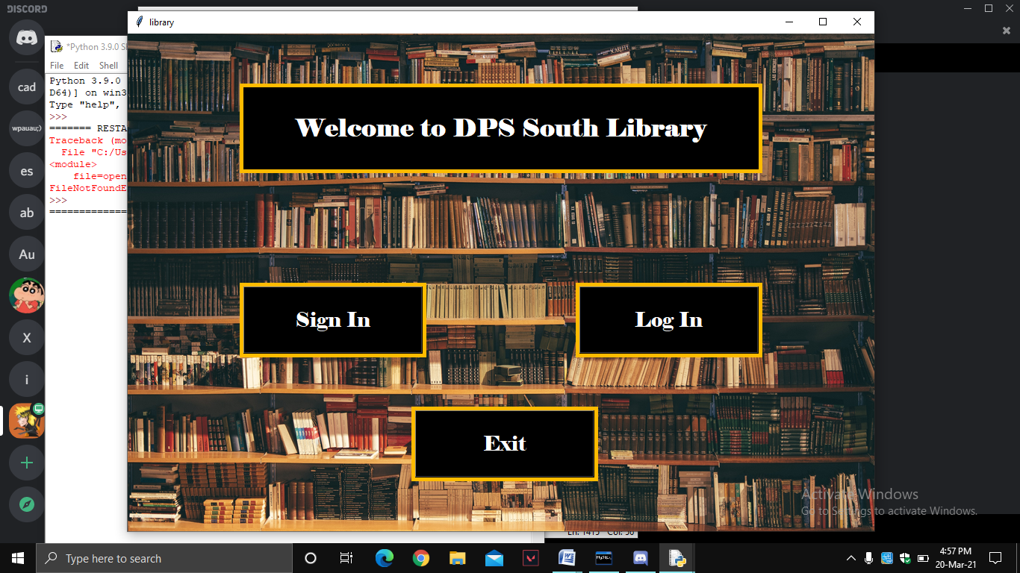

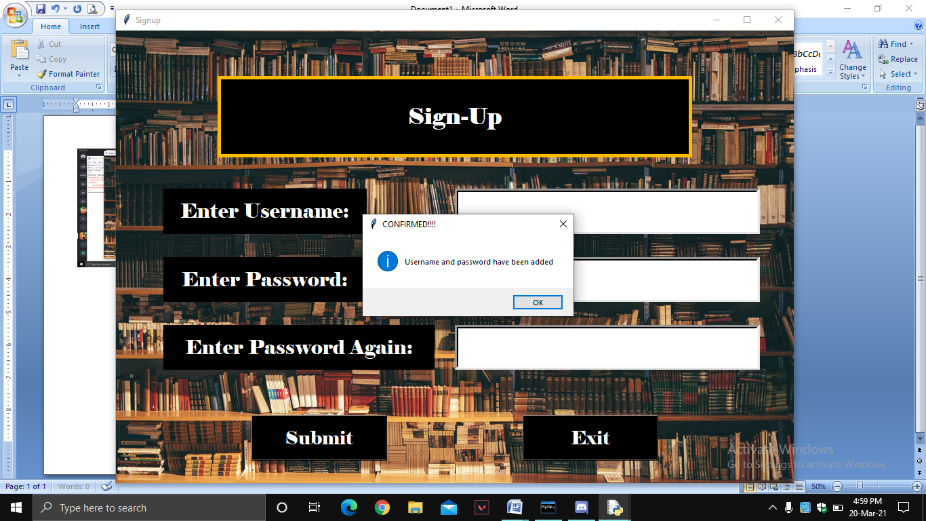

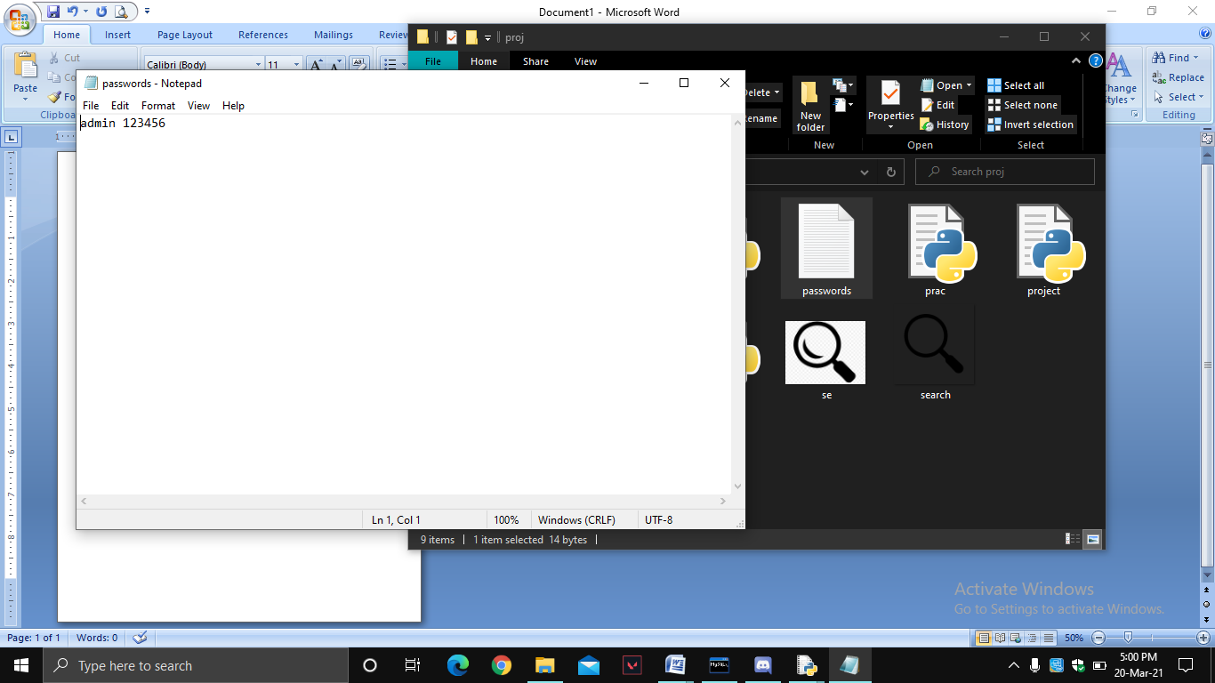

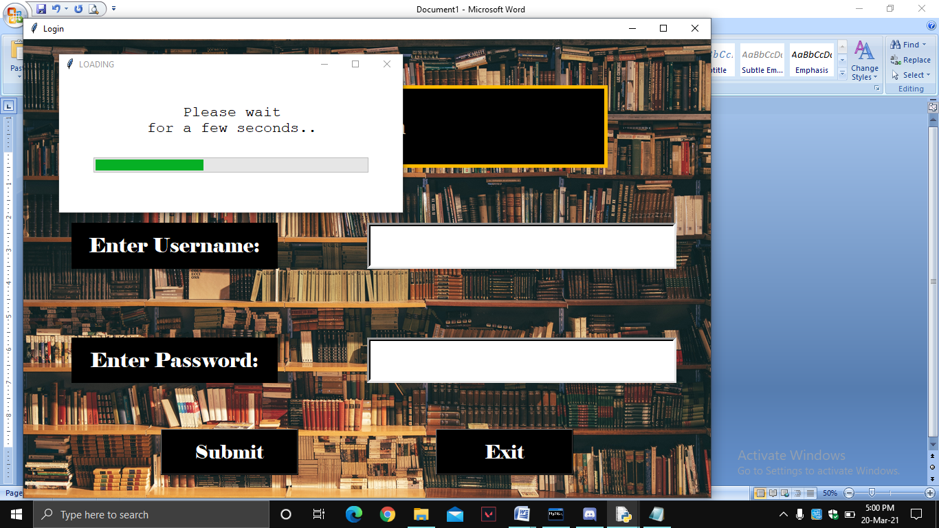

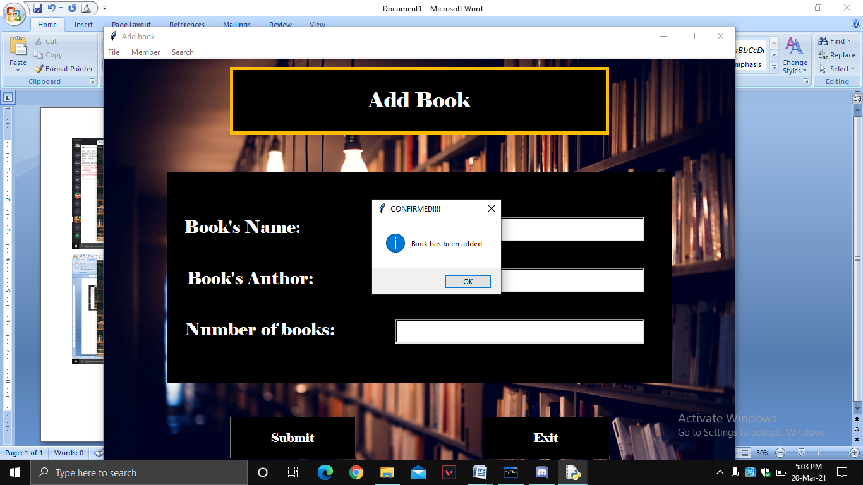

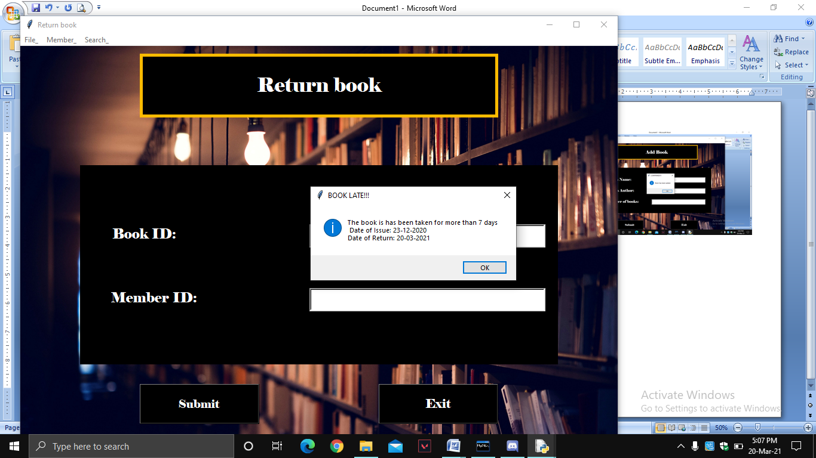

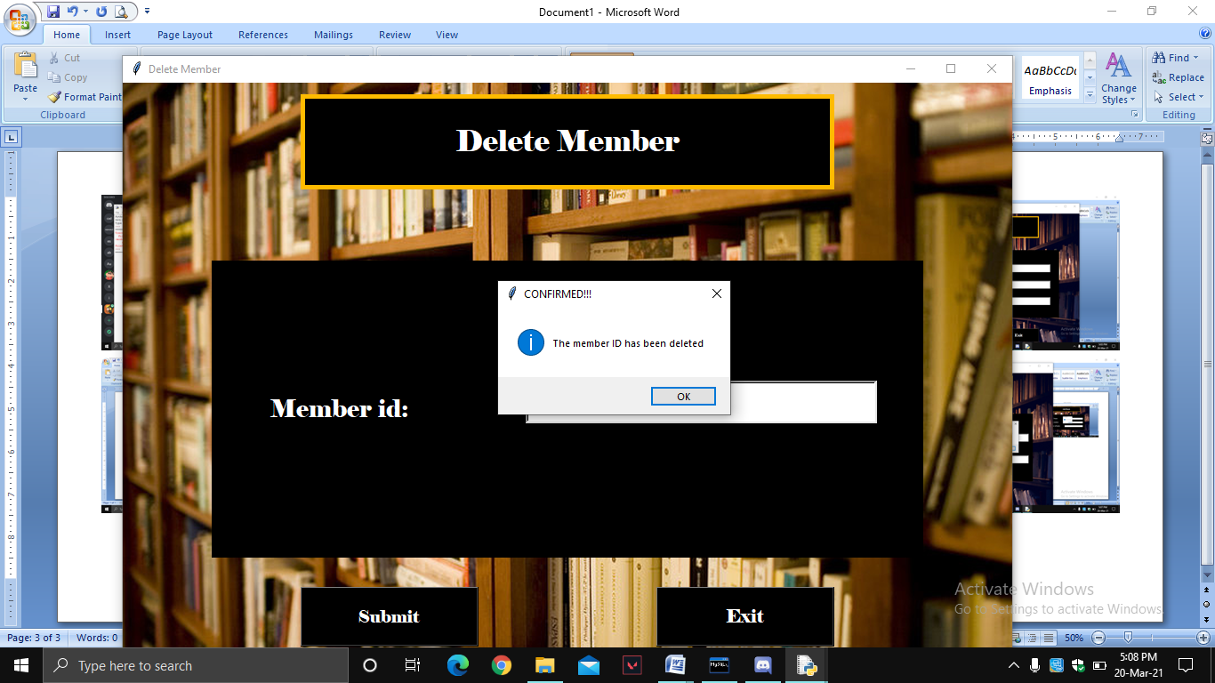

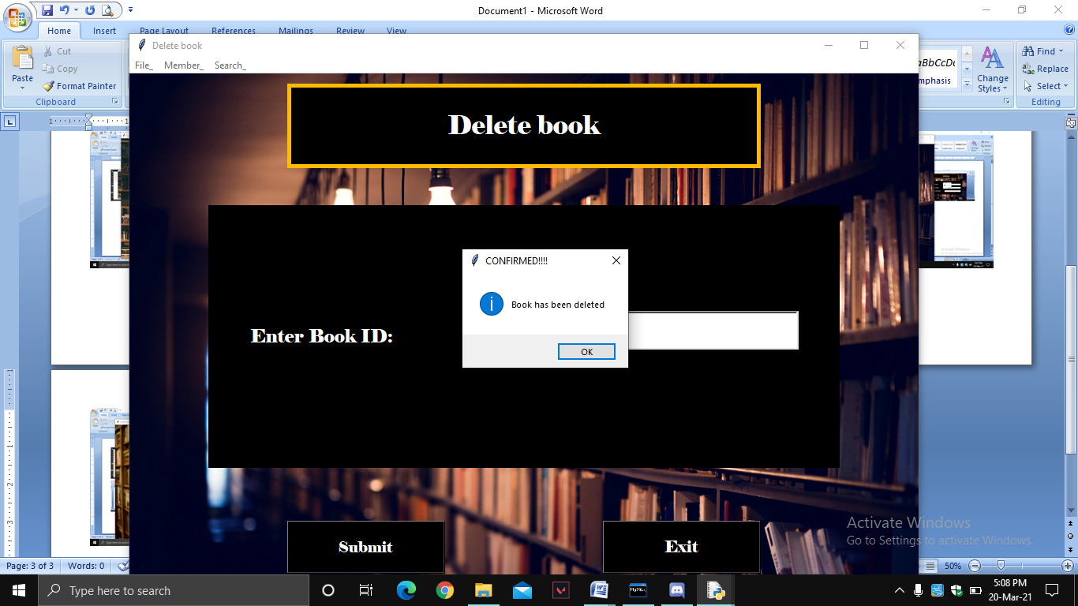

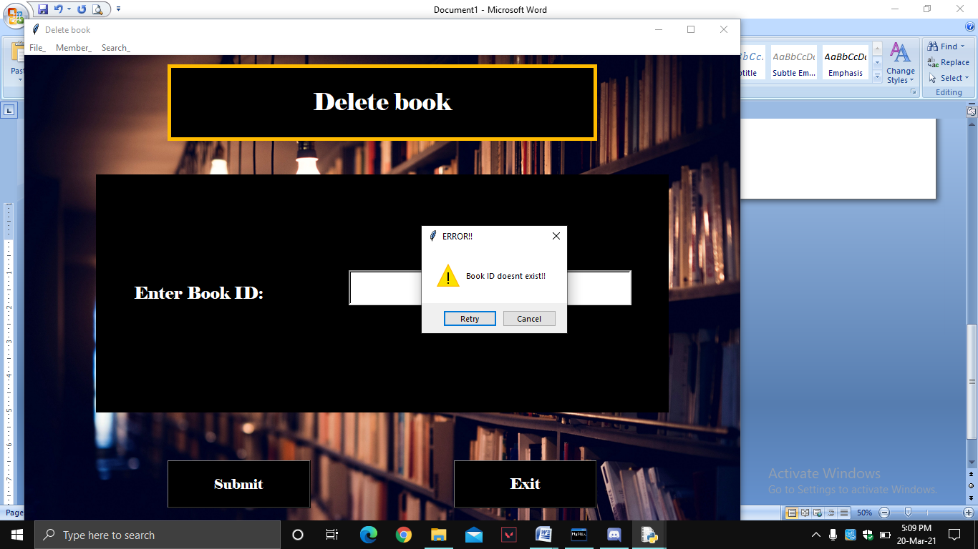

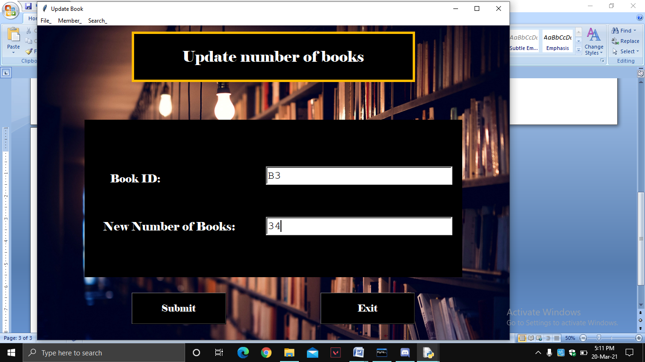

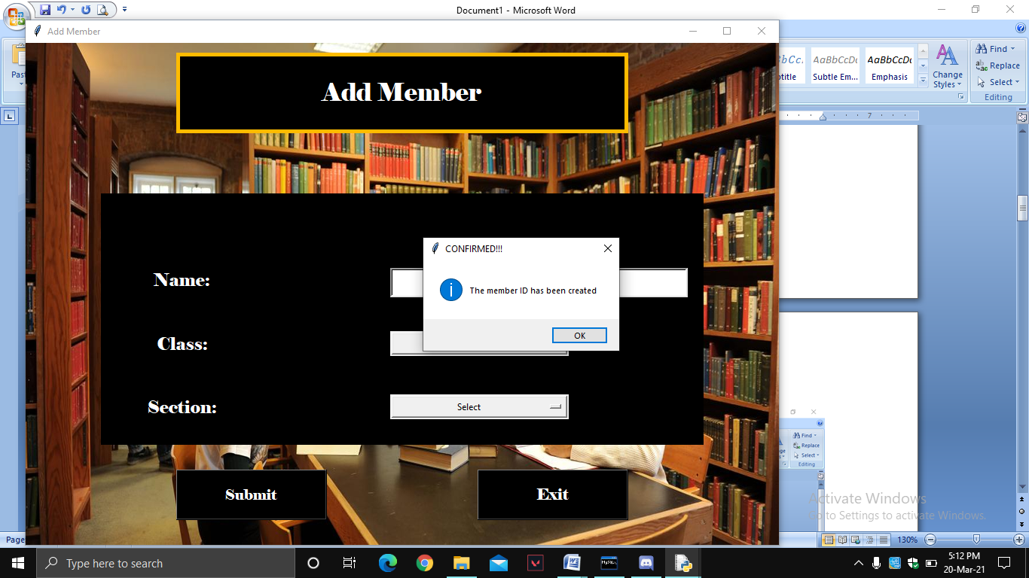

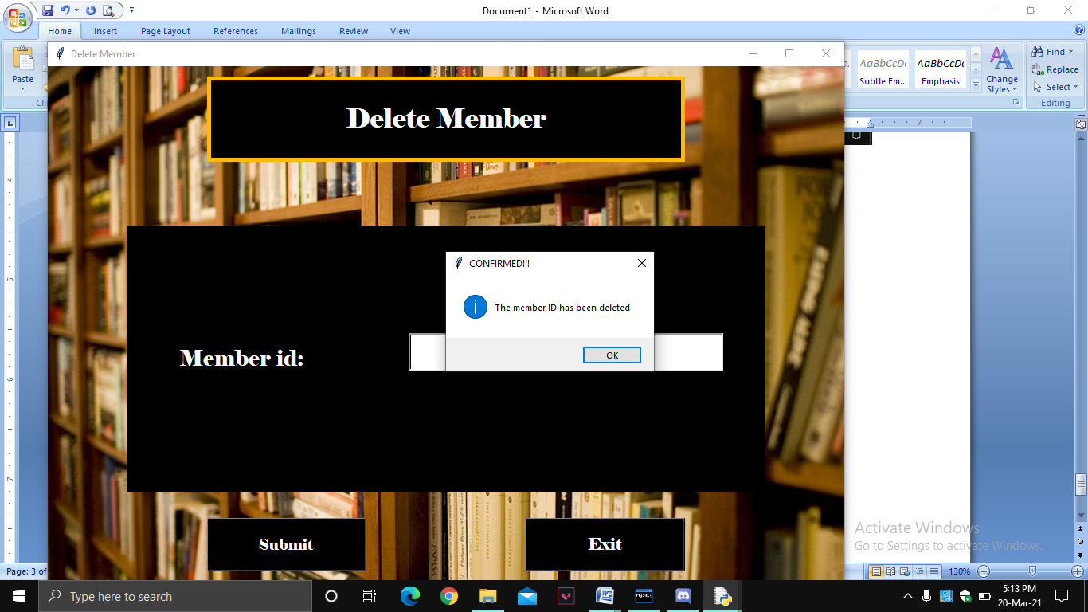

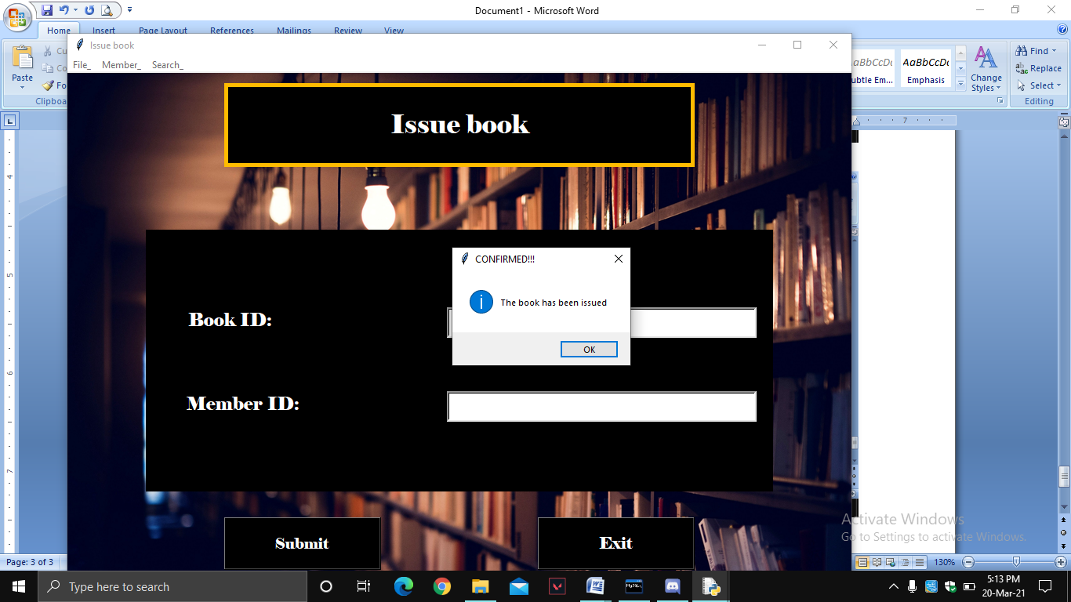

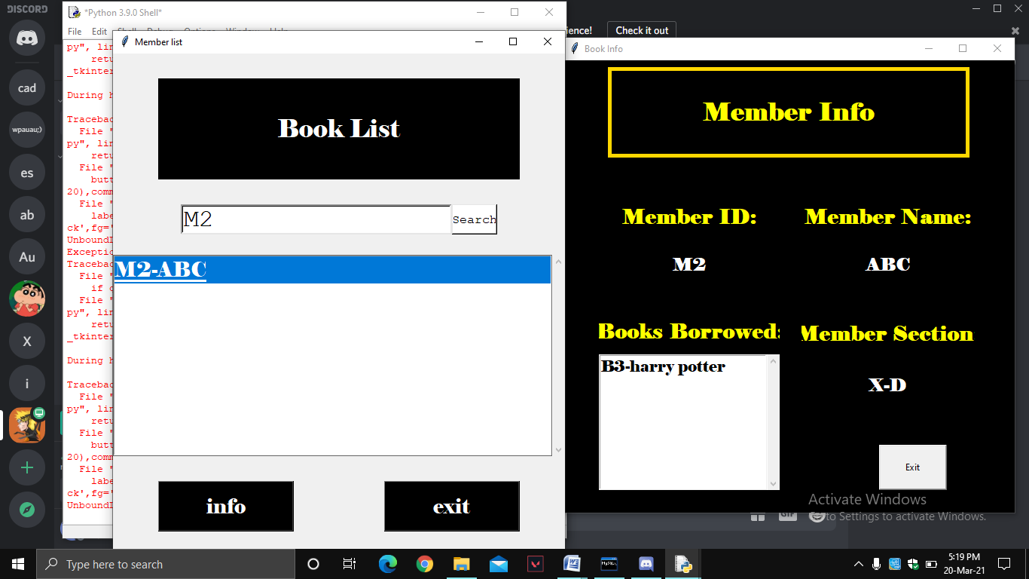

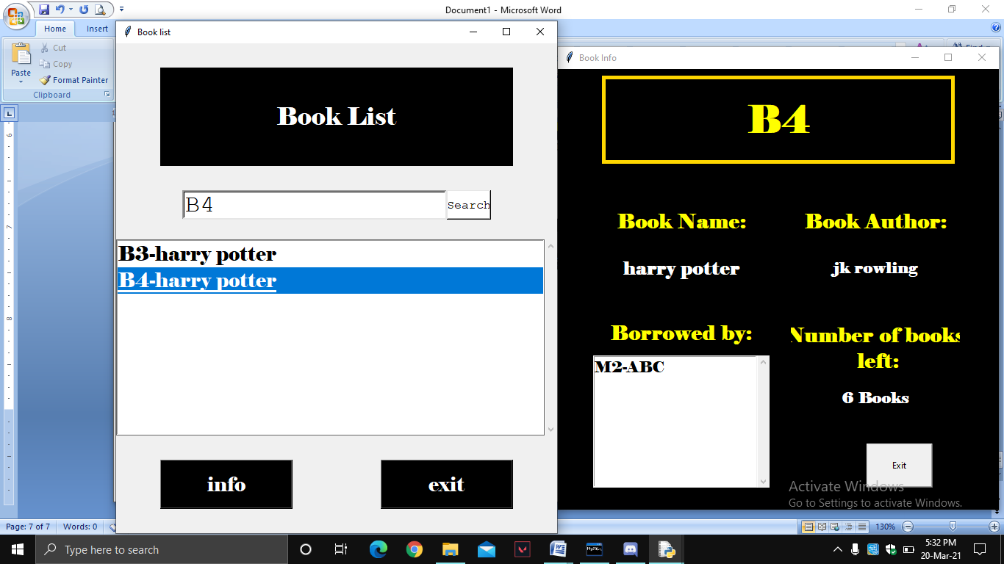

**References/ bibliography**

1. [**https://www.youtube.com/channel/UCFB0dxMudkws1q8w5NJEAmw**](https://www.youtube.com/channel/UCFB0dxMudkws1q8w5NJEAmw)
2. **https://data-flair.training/blogs/**